**Returns Putaway , Audit and Picking Blocking Logic**

| Activity: Audit | Putaway Status | | | | |  |
| --- | --- | --- | --- | --- | --- | --- |
| Audit Stages | Creation | Assigned | putaway | Incomplete | Complete |  |
| WO Creation | Y | Y | Y | Y | Y |  |
| WT Creation | Y | Y | Y | Y | Y |  |
| WT Assignment | Y | Y | Y | Y | Y |  |
| WO Picked | Y | N | N | Y | Y |  |
| WO In Process | Y | Y | N | Y | Y |  |
| WO Completed | Y | Y | N | Y | Y |  |
|  |  |  |  |  |  |  |
|  |  |  |  |  |  |  |
| Activity: Putaway | Audit Stages | | | | | |
| Putaway Status | WO Creation | WT Creation | WT Assignment | WO Picked | WO In Process | WO Completed |
| Creation | Y | Y | Y | Y | Y | Y |
| Assigned | Y | Y | Y | Y | Y | Y |
| Putaway | Y | Y | Y | N | N | Y |
| Incomplete | Y | Y | Y | Y | N | Y |
| Complete | Y | Y | Y | Y | N | Y |

**Box Blocking Logic Across Multiple Picklists/Putaway Tasks:** If a box is blocked under multiple picklist or putaway tasks, the system should follow a priority-based blocking logic.

For example:  
 If **Box B1** is blocked under **Picklist 1** but is free under **Picklist 2**, it should still be treated as **blocked**, since it is already blocked under Picklist 1.

In short, **once a box is blocked under any active task, it should remain blocked**, regardless of its status in other tasks.

**Home Button Functionality:** When the user clicks on the **Home** button, a confirmation popup should appear with the message:  
 **"All the details for this Work Task will be deleted. Do you want to continue?"**

* If the user selects **Yes**:  
  + The current **Work Task should be reset**, and the user should be **redirected to the Home Page**.
  + Any **data transfer to Manage (e.g., box-to-box transfer)** that has occurred as part of this Work Task should be **reverted**.
  + Any **entries pushed to Manage for this audit** must be **rolled back** to ensure data consistency.
* If the user selects **No**, the popup should close and the user should **remain on the current screen**.

**Skip Rack Functionality:** When the user clicks on **"Skip This Rack"**, the following backend actions should be triggered:

* The corresponding **Rack (Work Order)** should be **closed from the current Work Task ID**.
* The **status of the Work Order** should be updated to **"unaudited"**.
* This Work Order should then become **eligible for the creation of a new Work Task**.

**MRP Change will be Flagged as SKU mismatch Case.**

**Space Optimization Of UI**

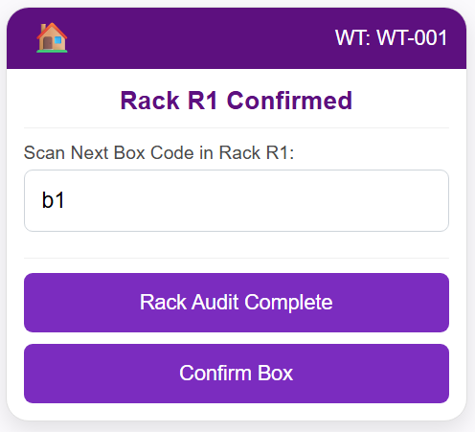

For the First Time User Scaning Rack and no boxcode are scanned , The Rack Audit Button should be Disabled

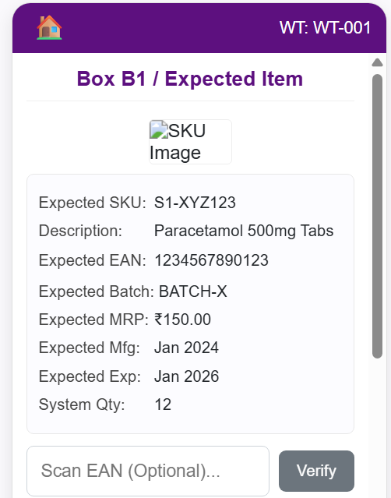

* Expected will be removed from all the places
* Expected MRP , Expected MFG , Expected EXP , System Qty will not be displaced
* Vendor Batch should added in the backend field , but currently in the UI it should be disabled (Will be enabled as per Business Requirement)
* Description name should not be shown
* 2 Row will be allocated for Description
* Once I click on the description details , it should show me the full description
* Beside Description , that space should be used to show image , and once i click on it , it should enlarge it and have the functionality of Zoom in /Zoom out
* Box B1 -> Boxcode B1
* Incase of Mandatory make the Scan EAN field Red , Whereas for other it will be grey out

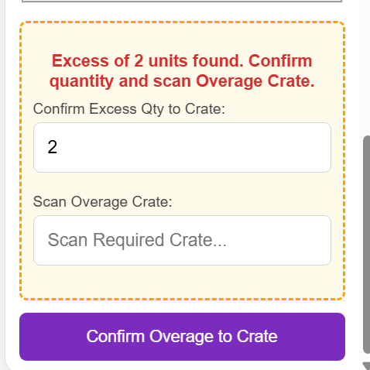

* Overage/Damaged Crate will be changed to crate.
* Incase of Damaged also they have to , confirm the Qty
* Incase of Damaged and Excess , they will have 2 field to confirm ; Confirm Excess Qty and Confirm Damaged Qty and then Scan Crate
* CTA at the end will be “Confirm to crate” for all the cases.

In case of User clicking on Complete Audit ,   
Show a warning that , Are you sure want to complete this Rack? . Don’t show any number of boxes . CTA will remain unchanged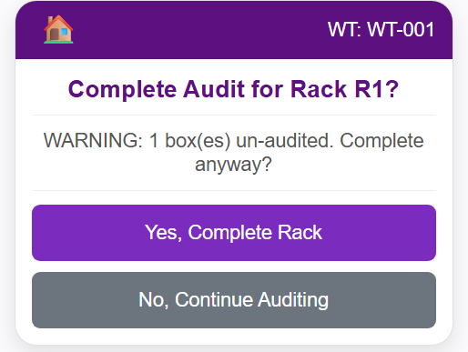

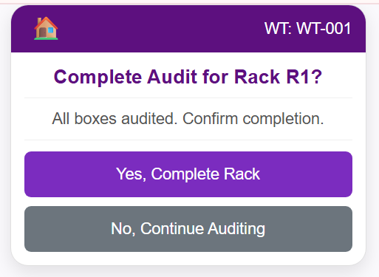

This page will not come , The User will confirm when they want to complete the audit , by clicking on the Rack Audit Complete button after the Box is audited

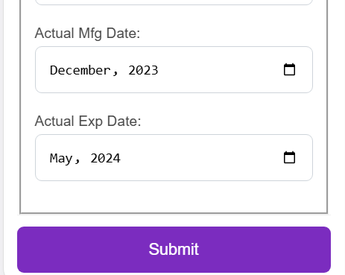

This is currently coming in MM/YYYY format need to change to dd-mm-yyyyas sap only accepts this format.

Need to share data to SAP in yyyy-mm-dd